**COIT20273: Software Development Project**

**Term 1, 2021**

**Artefact One**

**Lecturer / Tutor: Indra Seher**

**Unit Coordinator: Lily Li**

**Prepared by:**

**Bishal Budhathoki (12116421)**

**Laxman Khanal (12123129)**

**Niraj Prasad Timila (12125320)**

**Raken Shahi (12119317)**

Table of Contents

Purpose or reasons for undertaking the project. 3

Reasons for undertaking the project. 3

Problem aimed to be resolved. 3

Objectives and constraints. 3

Objectives 3

Constraint 4

In and out of scope activities. 4

Hardware and software requirements. 5

Hardware requirement in local server (Developer) 5

Software requirement in local server (Developer) 5

Hardware requirement in Client side. 5

Software requirement in Client side. 5

Team Members Roles and Responsibilities 6

Work breakdown structure (WBS) 7

Schedule (Gantt Chart) 8

Gantt Chart for overall project 8

Agile project backlog. 9

Burn down Chart. 9

Agile release plan. 10

Record of discussion with client. 11

User Stories 12

Use case Diagrams and description. 13

Risk estimation of the project 15

High level Overview of the budget. 19

Monitoring and reporting. 20

Bibliography 21

# Purpose or reasons for undertaking the project.

The School of Engineering and Technology wants to develop a platform where different companies can post their available job vacancies and allow its students to apply for the job.  
The main purpose of building this project is that the school wants to provide a better service for industry partners, students and stakeholders for easy exchange of the information.

## Reasons for undertaking the project.

**-**  Centralized system helps students and job providers to find the right option with minimum time and effort.

- This application will allow placement providers or industry partners to register their available job vacancies including description.

- Facilitate the students to maintain their personalized portfolio and get recommendation for the available vacancies.

- To provide a platform where employers and students can directly interact for getting better understanding which helps to make the right decision.

# Problem aimed to be resolved.

* Make the process of connecting students and job providers digital and as seamless as possible.
* Develop a responsive web application which has great user experience throughout the multiple device size screen.
* Provide the search feature which will allow us to find the correct resource quickly.
* Allow users to select interested categories which will show the related results.
* Upload CV so that the students do not need to send it each time they apply for a job.

# Objectives and constraints.

## Objectives

The main objectives are to build web-based system.

* The system should be able to store all the personal data in the centralized place and only can be accessed when needed.
* The system also will have filter system where admin should approve the vacancies before it gets posted to the system, this can help us to detect and minimize spam job vacancies.
* The system too consists of the forum where both student and employer can post questions and answer.
* Since it’s a web-based application it has mobile friendly feature and can be rendered according to the screen size of the devices.

## Constraint

Constraint is basically limiting factors which impact on the overall quality of the project. When we say constraint basically, we get instantly scope, time and cost in our mind. Slight increase or decrease in any of the three constraint can hinder the project. But by analysing our system requirement we are assure that we are within the limit of our time, scope and cost unless there are any changes in the future.

# In and out of scope activities.

|  |  |
| --- | --- |
| **In scope** | **Out scope** |
| Users should be able to upload CV. | Create profile analysing information from CV. |
| Responsive website can be rendered in every screen size. | Generate resume based on information on profile. |
| Employers can be able to see applications and directly contact for an interview. | Notification on new vacancies. |
| Both employer and student should be able to post on forums. | No private chatting features. |
| Users should be able to view jobs and apply according to their interest. | Native mobile applications. |
| User should be able to filter job categories. | User/ Company review |
| User should be able to search based on keywords. | Filter based on location and salaries. |

# Hardware and software requirements.

The hardware and software requirement are listed below:

## Hardware requirement in local server (Developer)

- Laptop/ Personal Computer/ Lab computer having minimum hardware configurations of 2GHz processor.

- 4GB Ram or above.

- Testing devices such as tablets, mobile and laptops.

## Software requirement in local server (Developer)

- Microsoft office (PowerPoint, Word, Project)  
- MYSQL Workbench

- Browsers (Google Chrome, Mozilla Firefox, Microsoft Edge)

- IDE (Visual Studio)

- Bitbucket

- Heroko (for deployment of client and server)

- Google Cloude (for MySQL database deployment)

- Postman

## Hardware requirement in Client side.

- PC/Laptop of minimum 2Ghz processor.

- 2GB Ram or above.

- Storage capacity of 16GB or more.

- Internet.

## Software requirement in Client side.

- Web browser (Google Chrome, Edge browser, Mozilla Firefox or other browsers).

- Smartphone or tablets browsers to test website.

# Team Members Roles and Responsibilities

|  |  |  |
| --- | --- | --- |
| **Team Members** | **Roles** | **Responsibilities** |
| Bishal Budhathoki | Project Manager, Backend Developer | 1. Managing the team and leading them.  2. Assigning tasks to team members.  3. Manage and follow the project deliverables.  4. Work on Server-side logic |
| Laxman Khanal | Backend Developer | 1. Server-side logic and integration with the front-end.  2. Manage APIs, mobile application and the web services.  3. Security and data protection implementations. |
| Niraj Prasad Timila | Front End Designer, Documentation | 1. Design and develop the front-end design and structure required for the application.  2. User experience and web design optimization.  3. Confirm that it follows latest technologies and tools.  4. Communicate with other members and do the documentation. |
| Raken Shahi | Tester, Database Designer and developer | 1. Test the prototype to end product.  2. Test the quality and data protection.  3. Select and design the database.  4. Perform queries on firebase database. |

# Work breakdown structure (WBS)

A Work Breakdown Structure (WBS) is a structure in which the tasks are divided and organised in hierarchical order that will be done throughout the duration of the project which has the impact on the outcome (Cohen, 2021). WBS for this project is shown in the below diagram.

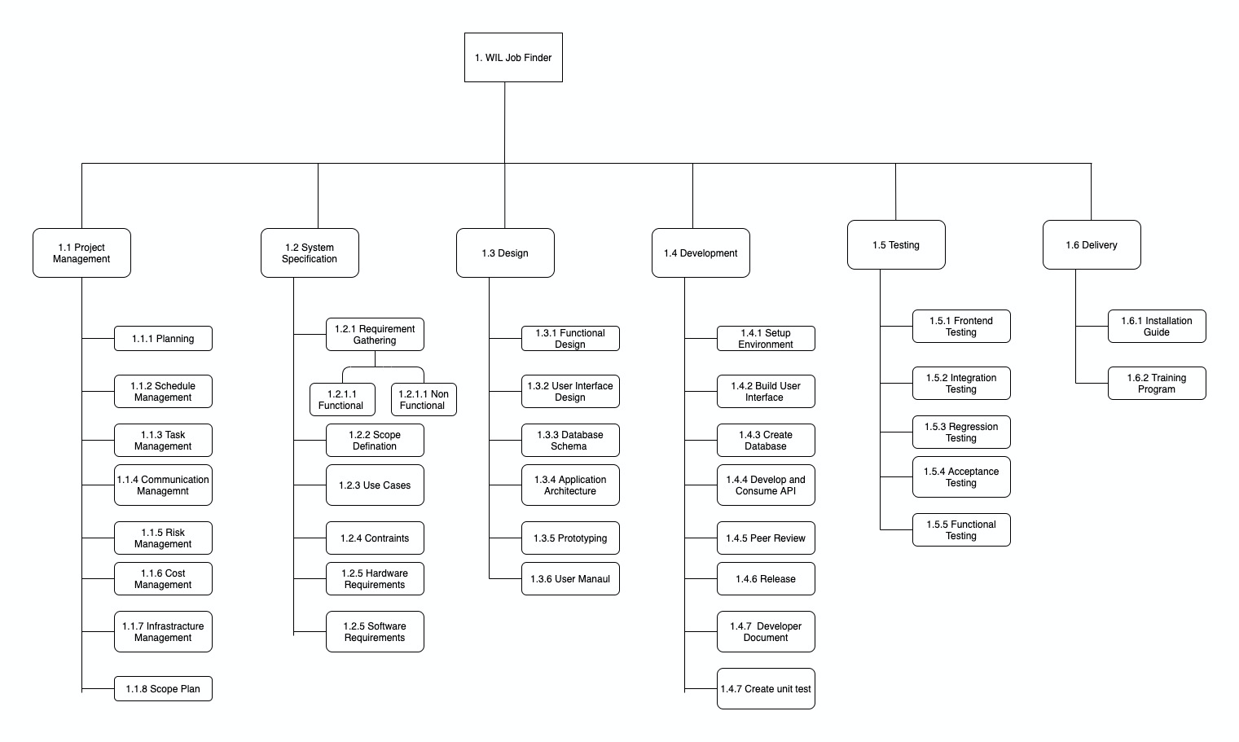

**Fig 1: Work Breakdown Structure**

# Schedule (Gantt Chart)

## Gantt Chart for overall project

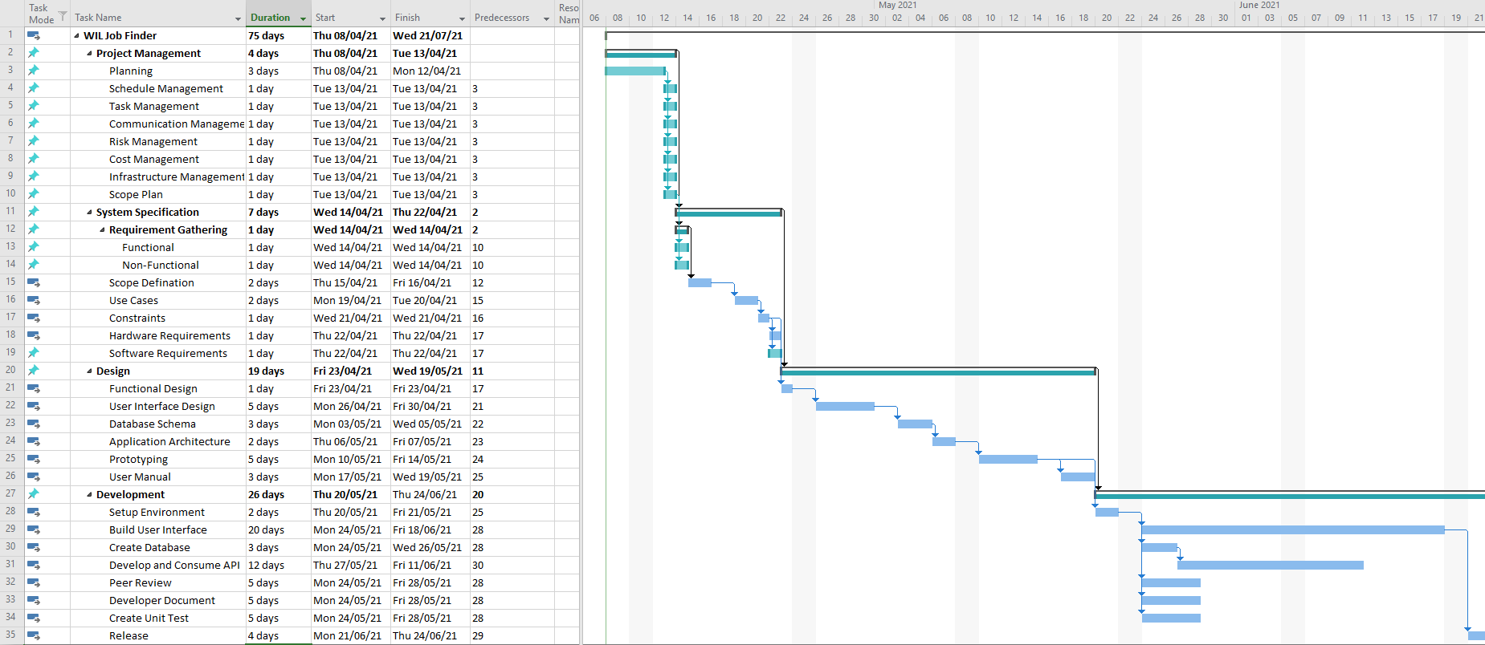

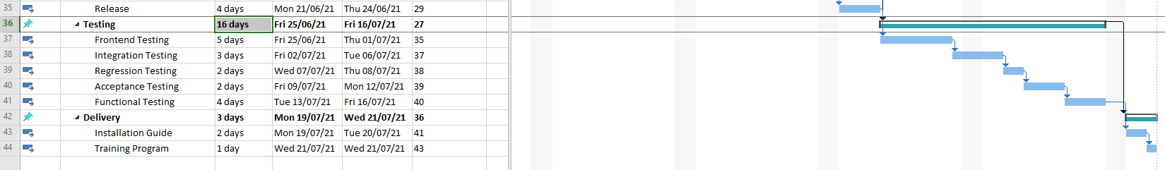

**Fig 2: Gantt Chart**

The above figure is of Gantt chart which shows the timeline of different project task.

## Agile project backlog.

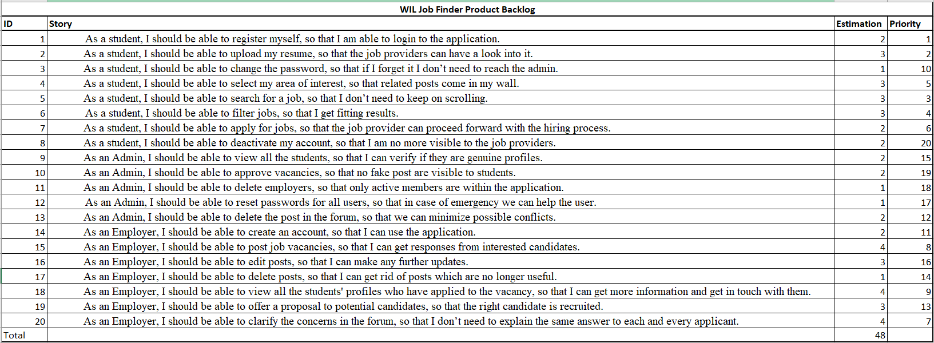

**Fig 3: Agile project backlog.**

The given image contains table that demonstrate the Product Backlog for WIL Job Finder. The estimated time to develop the product from the given user stories is 48 days but this is not a dependable tool and the estimated days can alter as the time goes by and different solutions to the problem could be approached.

## Burn down Chart.

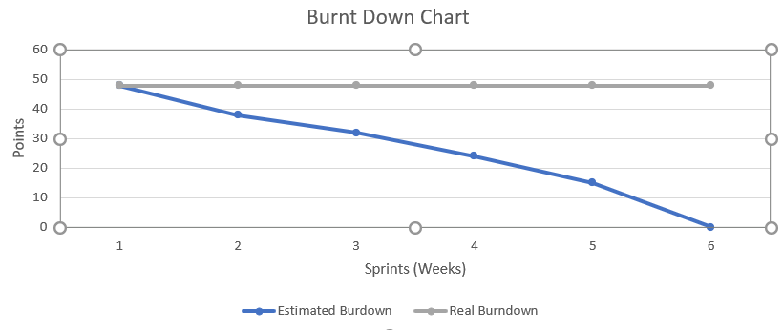

**Fig 4: Burndown Chart**

Above is the burn down chart of this project that goes by six weeks of development stage. Burndown is at an effort of 48 points as the build and development has not started. There can be changes in the given chart as the project starts to advance.

## Agile release plan.

|  |  |  |  |
| --- | --- | --- | --- |
| Version | Week | Features | Remark |
| 1.0.0 | 6 | * Register user * Login | User authentication/authorization for teacher/student/admin |
| 1.1.0 | 7 | * Post vacancies * Update/Delete vacancies * View open vacancies |  |
| 1.2.0 | 8 | * Search vacancies * Filter vacancies | Search based on keyword and filter vacancies based on category |
| 1.3.0 | 9 | * Create/update/delete profile * Upload resume |  |
| 1.4.0 | 10 | * Apply for job * View applied candidates profile |  |
| 1.5.0 | 12 | * Post/view comments in forum * Final Release | Fix bugs if any. |

As per the above table we will have 6 releases in each sprint with major functionality. Before each release the application pass through a series of testing methods (regression, acceptance, integration). Once it is verified, we roll out a new version with a release note. This is a high level release plan which may change based on the unexpected circumstances if any in future.

# Record of discussion with client.

|  |  |  |  |
| --- | --- | --- | --- |
| **ID** | **Time/Date** | **In Attendance** | **Description** |
| 1 | 1:00pm – 2:00pm  28/03/2020 | Raken Shahi, Niraj prasad Timila, Bishal Budhathoki, Laxman Khanal, Indra Seher | We had discussion with the representer of School of engineering and technology. Here we discussed about the requirements i.e., functional requirements and non-functional requirements of the project. |
| 2 | 02/04/2020 | All team members and Intra Seher | - Discussed on high level implementation approach and decided to go with web application (react as platform).  - Decided to use firebase for various cloud-based services.  - High level task division.  - Discussion on risk assessment. |
| 3 | 03/04/2020 | Email | The head of the school reached us via email on how to design the website, navigation and some other important notes. These points were noted and were added as to-do list for the project. |

# User Stories

A user story is a casual, general description of a software product written from the user's viewpoint. Its aim is to express how a software feature can benefit a client. In an agile system, it is the smallest unit of function. It's a goal, not a feature, expressed through the eyes of a software user (*User Stories | Examples and Template | Atlassian* 2021).

* As a student, I should be able to register myself, so that I am able to login to the application.
* As a student, I should be able to upload my resume, so that the job providers can have a look into it.
* As a student, I should be able to change the password, so that if I forget it I don’t need to reach the admin.
* As a student, I should be able to select my area of interest, so that related posts come in my wall.
* As a student, I should be able to search for a job, so that I don’t need to keep on scrolling.
* As a student, I should be able to filter jobs, so that I get fitting results.
* As a student, I should be able to apply for jobs, so that the job provider can proceed forward with the hiring process.
* As a student, I should be able to deactivate my account, so that I am no more visible to the job providers.
* As an Admin, I should be able to view all the students, so that I can verify if they are genuine profiles.
* As an Admin, I should be able to approve vacancies, so that no fake post are visible to students.
* As an Admin, I should be able to delete employers, so that only active members are within the application.
* As an Admin, I should be able to reset passwords for all users, so that in case of emergency we can help the user.
* As an Admin, I should be able to delete the post in the forum, so that we can minimize possible conflicts.
* As an Employer, I should be able to create an account, so that I can use the application.
* As an Employer, I should be able to post job vacancies, so that I can get responses from interested candidates.
* As an Employer, I should be able to edit posts, so that I can make any further updates.
* As an Employer, I should be able to delete posts, so that I can get rid of posts which are no longer useful.
* As an Employer, I should be able to view all the students' profiles who have applied to the vacancy, so that I can get more information and get in touch with them.
* As an Employer, I should be able to offer a proposal to potential candidates, so that the right candidate is recruited.
* As an Employer, I should be able to clarify the concerns in the forum, so that I don’t need to explain the same answer to each and every applicant.

# Use case Diagrams and description.

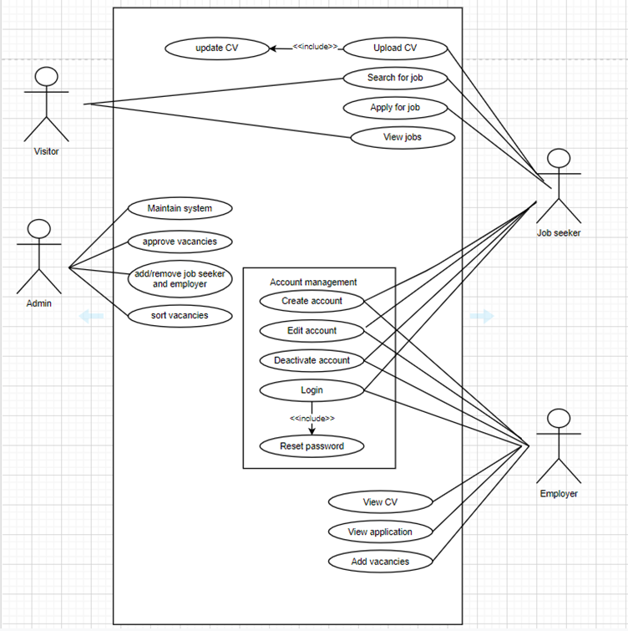

**Description:**

Actor: Employer

* Employer can create and deactivate the account.
* Employer can add and edit the vacancies.
* Employer can view CV.
* Employer can view application.

Actor: Admin

* Admin maintains system.
* Admin can sort and approve vacancies.
* Admin adds or remove job seeker or employer.

Actor: Visitor

* Visitor can search for the job.
* Visitor can view the job.

Job seeker

* Job seeker can search and view the job.
* Job seeker can upload their CV.
* Job seeker can apply for the job.
* Job seeker can create or deactivate their account.

# Risk estimation of the project

According to Project Management Institute, project risk is defined as an unforeseen occurrence or circumstance which if happens leads to positive or negative impact on one or more project goals. The various risk which might occur while building the project and their mitigation strategy are as shown below:

|  |  |  |  |  |  |
| --- | --- | --- | --- | --- | --- |
| **No.** | **Risk Type** | **P: Probability (0-1)** | **I: Degree of Impact (1-10)** | **Jeopardy (P*I)**  If >6: Action required | **Response plan** |
| 1 | Natural Disasters and Data loss | 0.1 | 7 | 0.7 | Backup the data in a safe and secure place such as cloud and local drive. If one fails to provide data, then others will have the backup data. |
| 2 | Technical faults | 0.5 | 8 | 4 | Scheduled maintenance and consult with experts. |
| 3 | Workload to a team member | 0.6 | 7 | 4.2 | Time management and split the work fairly to all team members. |
| 4 | Team members fall ill. | 0.6 | 8 | 4.8 | Maintain exercising habits, take care of health and take low stress. |
| 5 | Requirements misunderstanding | 0.9 | 8 | 7.2 | Have a group discussion and clear out all the misunderstandings. |
| 6 | Internet access Failure | 0.3 | 7 | 2.1 | Contact Internet service Provider and check router configuration. |
| 7 | Inadequate skill | 0.9 | 9 | 8.1 | Find the skills of each member and separate the task according to their skill. Training must be provided if necessary. |

**Quality Assurance Plan**

It can be defined as the pre-planned document which are developed by the project team which if implemented ensures that the final product follows all requirements resulting in the highest quality product (*What Is A Quality Assurance Plan? - Sofeast* 2020). Not only should the product satisfy all consumer expectations, but it should also meet the company’s goals and objectives.

1. **Quality Roles and Responsibilities**

|  |  |  |
| --- | --- | --- |
| **Role** | **Name** | **Quality Responsibility** |
| Project Owner | School of Engineering and Technology (CQU) | Advising, checking, monitoring, auditing. |
| Software Developer | Bishal Budhathoki, Laxman Khanal, Niraj Prasad Timila and Raken Shahi | Quality Analyst and functional testing. |
| Lily Li | Course Coordinator | Quality Audit |

1. **Quality Metrics**

|  |  |  |  |
| --- | --- | --- | --- |
| **Metric** | **Standard** | **Measuring Method** | **Quality Criteria** |
| Website Responsiveness | Website should be adaptive to the screen size. i.e., website must properly display its UI on laptops, mobile, tablets. | Testing | Must be responsive to all screen size. |
| Functionality | Website should be bug free as far as possible. Scripts must function properly including links. | Testing | The links must redirect users to the proper webpage. It must not have dead ends. |
| Reliability | Review whether the website is doing good or not according to contract. | Testing | Up to 4 error per year. |
| Performance | Page loading, navigation should be fast. | Testing | Faster loading response of website with time less than 0.5 seconds. |
| User Interface | Simple and clean design. | Auditing and testing. | The UI of the website must be consistent and clean. Different designing tools such as photoshop, illustrator, figma etc. |
| Maintenance | Minimum maintenance cost | Auditing | The cost for maintenance must be very low. Fixed fee maintenance cost for hardware and software and shouldn’t cross $1500 per year. |
| Security | Proper authorization of admin and users. | Testing | Permission for access to system according to the role. |

# High level Overview of the budget.

The method of monitoring and recording revenue and expenditures is known as budget management. In every organization or project, we need a proper budget plan and the management because we have certain limitations to afford to accomplish something.

**Manpower cost overview**

|  |  |  |  |  |  |
| --- | --- | --- | --- | --- | --- |
| **Id** | **Team Member** | **Hours/Week** | **Total Week** | **Hourly Rate ($)** | **Total($)** |
| 1 | Niraj Prasad Timila | 20 | 10 | 40 | 8000 |
| 2 | Raken Shahi | 20 | 10 | 40 | 8000 |
| 3 | Bishal Budathoki | 20 | 10 | 40 | 8000 |
| 4 | Laxman Khanal | 20 | 10 | 40 | 8000 |
|  | Total | 80 | 40 |  | 32000 |

**Miscellaneous cost overview**

|  |  |  |
| --- | --- | --- |
| **Id** | **Title** | **Cost** |
| 1 | Development and deployment infrastructure | $3000 |
| 2 | Third party paid services | $2000 |

This project being a part of a university project we will be using free or open-source technology whenever possible. Despite this fact we will have the cost of $37000 which is expected to be overcome within 2 years if our application goes live in public.

# Monitoring and reporting.

Monitoring is basically checking the progress of quality of the software over a certain amount of time, whereas controlling is the process of checking the errors and taking corrective action whenever needed.

In Order to properly monitor and control our project we have executed in following ways:

Team member meeting: project team members including team leader meetings have been organized to make sure every task is right on the track. Furthermore, the purpose of our meeting will be to share information, discuss the problem faced in the project and to find out the solution to tackle our problem.

Weekly report: Every week project leader prepares the weekly report for the tutor which includes tasks completed successfully, tasks needed to be done and solution technique used to tackle to solve the problem.

# Bibliography

Cohen, E 2021, *What is WBS (Work Breakdown Structure) in Project Management?*. viewed 6 April 2021, <https://www.workamajig.com/blog/guide-to-work-breakdown-structures-wbs>.

Hillson, D. (2014). Managing overall project risk. Paper presented at PMI® Global Congress 2014—EMEA, Dubai, United Arab Emirates. Newtown Square, PA: Project Management Institute.

*User Stories | Examples and Template | Atlassian* 2021. viewed 7 April 2021, https://www.atlassian.com/agile/project-management/user-stories.

*What Is A Quality Assurance Plan? - Sofeast* 2020. viewed 1 April 2021, https://www.sofeast.com/glossary/what-is-a-quality-assurance-plan/.